THEMATIC SHADOW REPORT ON FAMILY-RELATED ISSUES IN BRAZIL
88th CEDAW Session, May 2024

Global Campaign for Equality in Family Law, CLADEM/Brazil, and GAMBE's Submission to the Committee on the Elimination of Discrimination Against Women (CEDAW) on Brazil’s periodic report for the 88th CEDAW Session, May 13th - 31st.

Following the briefing to the CEDAW Committee in October 2023 on Article 16 and family law, the Global Campaign for Equality in Family Law (GCEFL), CLADEM/Brazil, and GAMBE respectfully submit this thematic shadow report to contribute to the analysis of Brazil’s compliance with the Convention on the Elimination of All Forms of Discrimination against Women (“the Convention”). In this report, we focus on articles 1 (equality), 2 (non-discrimination), 5 (gender stereotypes), 11 (employment), and 16 (marriage and family) of the Convention, raising issues related to i) the use of ‘false’ parental alienation syndrome and related concepts by Brazilian courts in decisions regarding child custody in highly disputed divorce cases, and ii) the situation of Brazilian mothers living abroad in contexts of domestic abuse who return to Brazil and are accused of international kidnapping due the obligations arising from the Hague Convention ratification. We urge the CEDAW Committee to kindly consider granting more time and specific attention to Article 16-related matters during the Constructive Dialogues.

Summary of issues:
Related CEDAW Arts. | Issues Related to Family Law / Practices | Details
Arts. 1, 2, 16 | Marriage:  Child marriage | Both girls and boys who are 16 years old can be married with the consent of either their parents or their legal representatives. Civil Code, 2002, changed by Law 13.811/2019. Brazil has a high rate of child marriage (26%), often as a way to hide domestic abuse and sexual violence, often obstructing access to legal abortion services.
Art 1, 2, 5, 16 | Child custody:  Parental Alienation Syndrome | Law No. 12,318, 2010 defines parental alienation as an interference by one parent with their child’s relationship with the other parent, causing the child to repudiate the parent. In cases of parental alienation, the court may fine the parent accused of alienating the child and reduce or remove their custody of the child.  This law is weaponized in custody and domestic violence cases, reinforcing and promoting gender stereotypes in courts, resulting in custody being granted to abusers.
Arts. 1, 2, 11, 16 | Parental leave | The law grants 120 days of maternity leave and just 7 days of paternity leave. Consolidated Labor Laws, Art. 392; Constitution of the Federal Republic of Brazil, Art. 7 (XVIII); Temporary Constitutional Provisions Act, Art. 10(II)(b)(1).  There is no paid parental leave.

KEY ISSUE OF CONCERN 1: ‘False’ Parental Alienation Syndrome

Broadly speaking, the Latin America and the Caribbean (LAC) region does not have explicit discriminatory laws when it comes to family laws. The region has experienced a process of constitutionalization of civil law with equality in the family being included in the constitutions approved in the 1980s after the end of the dictatorships in the region. This was the case in Brazil where feminist activism (known as the "Lipstick lobby") successfully included equality in marriage and family planning as fundamental rights in the 1988 Constitution. As a result, many laws were reformed to adjust to the equality between men and women in families.

Despite such efforts, however, we notice that biased practices and public policies still affect women, in particular women who are mothers, disproportionally. In line with a religiously inspired perception that women are equal but at the same time different from men - "essentialist difference feminism," - Brazilian women are perceived as the primary caregivers, in charge and responsible for all the care work and household chores. This socio-cultural value tends to overburden women with non-paid work, resulting in less participation in the workforce and political spaces of decision.

With this context of formal equality but no material or substantial equality in consideration, we reflect on and call for reforming social-cultural contexts that perpetuate discrimination against women despite laws ensuring equality. We understand this task of changing socio-cultural bias regarding gender roles as key to ensuring women's rights, as defined by the CEDAW and Belém do Pará Conventions.

Child marriage
One example of these inequalities in the family refers to child marriage. A recent change in the Civil Code (supra mentioned) forbids marriage for those under the age of 16 years old, except in cases the involved obtain parental permission. Despite this regulation, 36% of the female population in the country gets married before reaching 18 years of age, registering an average of 43 marriages of teenage girls under 18 years old every day. Just in 2022, Brazil had 15,8 thousand child marriages, and 260 of these involving girls younger than 15.

Data also shows that 95,4% of girls between 16 and 17 years old marry men older than 18. Often, such unions hide situations of domestic violence and sexual abuse, including to prevent young victim-survivors of rape from accessing legal abortion services. Here we see how traditional gender stereotypes still prevail in the country, where marriage is often seen and sought as a solution for cases of sexual violence resulting in pregnancy, or even in cases of unplanned pregnancies in youth.

Parental alienation syndrome
CLADEM's groundwork has found the approval of laws related to false "parental alienation syndrome (PAS)," or the use of legal arguments that incorporate the core ideas of this syndrome in judicial decisions in multiple countries in the region. The use of the concept of parental alienation syndrome is highly contested for not being a recognized mental illness and an outstanding lack of scientific evidence to back up its use in the judicial system.

This concept was first coined by Richard Gardner in the 1980s, but he did not follow minimal standards of scientific investigation, which was the main reason his theory did not make its way into academic journals and has been openly rejected by health professionals in general and authorities. Regardless, PAS has been emerging as a prominent issue in custody cases, dividing legal and medical professionals and being claimed by mothers and their legal representatives as an instrument to refute the mother's claims of abuse and violence endured previous to the divorce. This is not by chance, as Gardner's definition of PAS is permeated by gender biases and sexism since he describes it as: "a "syndrome" whereby vengeful mothers employ child abuse allegations as a "powerful weapon" to punish the ex and ensure custody to themselves." In short, Gardner claimed (solely based on his own clinical observation) that the sexual abuse allegations brought up by mothers in custody cases would be false in 90% of the cases.

Parental alienation syndrome (PAS) is recognized as an international human rights violation with severe implications for women's and children’s rights. In 2023, the UN Special Rapporteur on Violence Against Women and Girls concluded that while PAS is characterized as a pseudo-scientific form of psychological abuse perpetrated by women against men, in reality, it has been weaponized to obscure accusations of sexual and emotional abuse perpetrated by male partners against women and their children. As stressed by the Special Rapporteur, "Parental alienation is used in family law proceedings by abusers as a tool to continue their abuse and coercion and to undermine and discredit allegations of domestic violence made by mothers who are trying to keep their children safe.”

Brazil’s Law No. 12,318, of August 26, 2010, defines parental alienation as “the interference in the psychological development of the child or adolescent promoted or induced by one of the parents, by the grandparents or by those who have the child or adolescent under their authority, custody or supervision to refute a parent or harm the establishment or maintenance of links with the parent.” It lists several examples of parental alienation, which include hindering the other parent’s exercise of parental authority, hindering contact between a child and the parent, filing a false complaint against the parent, or changing the home to a distant location without justification. Where parental alienation is found, the court may reduce or remove the parent’s custody of the child, stipulate a fine for the alienator, and order psychological and biopsychosocial monitoring.

Enactment of this law has led to a proliferation in the use of parental alienation in Brazilian family courts, enabling fathers accused of domestic violence and sexual abuse to successfully diminish the credibility of mothers bringing these claims, and gain custody of the children. The use of parental alienation in judicial proceedings to contradict reports of violence results in reduced access to justice and excessive financial hardships through fines.

Indeed, Brazil, during its previous CEDAW Review in 2022, conceded in its State party report that, although Law 12,318/2010 was “approved to protect the child, concrete unfair situations were observed.” Despite intense civil society mobilization to repeal the PAS law at least since 2016/2017, the Federal Legislative Power in Brazil passed, and the Executive Power sanctioned, Law No. 14,340, 2022 which changes Law No. 12,318/2010 modifying legal procedures to be adopted in cases of parental alienation; also changing Law No. 8,069/1990 (Child and Adolescent Statute), to establish additional procedures for the suspension of family power. We highlight, however, that such modifications resulted in a reinforcement of the parental alienation institute, further stigmatizing women who are mothers and obstructing their right to exercise motherhood. Additionally and more concerning, this new law expanded the concept of parental alienation by also placing it within the Child and Adolescent Statute.

Gender stereotypes, including those claiming that women are “hysterical” or crazy, lie at the heart of PAS. This Committee has emphasized the need for states to address and adequately deal with gender stereotypes and prejudices in judicial systems. The Committee has also commented on PAS in concluding observations issued to Costa Rica, Italy, Uruguay, and New Zealand. In those, it urged State parties to abolish the use of parental alienation by courts in child custody cases. It further recommended that “the rights or claims of perpetrators or alleged perpetrators during and after judicial proceedings…should be determined in the light of women’s and children’s human rights to life and physical, sexual and psychological integrity, and guided by the principle of the best interest of the child.”

Research on PAS is difficult due to the protection of personal information regarding children, but evidence shows that PAS has been disproportionally used against women, at the moment they report domestic abuse. According to Severi, from 913 cases decided by the São Paulo State Court (2000 - 2019), 29% involved some form of domestic violence and PAS was invoked by 46% of the fathers. Overall, no expert evidence was presented in such cases, but when it was conducted, it was often applied to the mothers, who were submitted to mental health evaluations in 82% of the cases. Once mothers claimed sexual abuse against the children, the father argued she was practicing parental alienation in 56% of the cases, resulting in women being considered the alienating parent in 70% of the cases.It is important to remember that evidence shows that the moment of divorce is key for women suffering domestic abuse, since it is one of the most dangerous and where she needs more support, rendering the moment of determination of custody a very sensitive one.

Using and accepting false PAS, often as the only evidence in judicial proceedings, breaches Brazil’s obligation to act with due diligence to prevent and respond to gender-based violence and discrimination against women; fails to ensure victims-survivors’ access to justice and adequate judicial protection; revictimizes through institutional violence, by denying women their parental rights, negatively impacting women and children’s fundamental rights; and reinforces gender-biased perceptions and stereotypes about women within judicial procedures.

Additionally, we have observed that the enforcement of the PAS Law and any related concepts by the justice system in Brazil has been undermining the Maria da Penha Law, which addresses domestic abuse in Brazil. By assuming that reports of domestic abuse and sexual abuse are false claims, presented due to a process of parental alienation, family courts are acting against the Maria da Penha Law and other policies that require the victim-survivors to be heard and believed. In 2018, Law n. 13.715/2018 was passed to strengthen protection within the family in cases of domestic abuse, removing parental rights in cases of domestic violence. However, once parental alienation syndrome or related concepts are claimed by the abuser, this law is endangered. As we see, despite an array of legislation protecting women's and children's rights, persisting gender stereotypes that ground the ideas of parental alienation as the work of manipulative, revengeful mothers endanger women's and children's human rights protections, in wide contravention of Brazil’s obligations under CEDAW.

ONGOING REFORM PROCESS:
Currently, there are more than 20 bill proposals on the matter of parental alienation being discussed at the Brazilian Congress. Two of them focus on revoking Law No. 12,318, 2010: PL nº 2235, de 2023, e o PL nº 1372, de 2023. We observe, however, that even if the law is revoked, gender stereotypes persist within the Brazilian courts, and the mere exclusion of the law from the Brazilian legal order will not address the situation of severe institutional violence mothers and children have been experiencing in Brazil. Additionally, the ongoing review of the Brazilian Civil Code contains provisions aiming to ensure the retention of the systematic use of parental alienation and related concepts.

KEY ISSUE OF CONCERN 2: THE IMPLEMENTATION OF THE HAGUE CONVENTION WITHOUT A GENDER PERSPECTIVE

The Hague Convention on Civil Aspects of International Child Abduction (wrongly translated in Brazil as kidnapping), was approved 50 years ago and is currently enforced in more than 100 countries around the world. Originally, this treaty sought to protect their citizens with children from a foreign father, who could then take them away and cross borders without authorization and without leaving a trace. This practice was growing against women and children in those countries in the 1970s, which requires, in fact, a quick response from authorities at an international level. Thus, the protocol activated by the 1980 Hague Convention was born to facilitate communication between the country of origin and destination in abduction cases. However, in 2015 alone, more than 8 in 10 abduction accusations fell on foreign mothers, according to official statistics. There were more than 73% of cases registered in the world that year, almost triple the number against male parents, and in a growing trend that includes 15,000 migrant women accused of “abducting” their own children under article 28 in the last decade.

Often, these women seek to return to their country of origin with their children to escape domestic abuse suffered within their marriage or common law union relationships. Data shows that 90% of the Brazilian women accused of internationally kidnapping their children under the Hague Convention suffered domestic abuse and were fleeing such abuses when they traveled to Brazil. The Hague Convention has no explicit mention of domestic abuse as an exception to the repatriation of children, and these Brazilian women living abroad often are not familiar with the local justice systems or suffer combined biases for being women and Brazilian/immigrants. We note that 48 out of the 103 signatories of the 1980 Hague Convention criminalize these types of abduction. When the children are returned to the country the mother and the children were fleeing from, where they had no support network or help to leave the abusive relationship, the mother who follows the children in trying to obtain custody rights will likely respond to criminal charges before the local courts or even go to jail awaiting trial. This abrupt separation from the primary caregiver, often exposing the children to the care of abusive parents or parents who were never very involved in childbearing, has been causing harm to the children's development.

GAMBE is a non-profit organization that supports Brazilian women living abroad, particularly the ones suffering domestic abuse. From 2020 to 2022, GAMBE assisted 155 Brazilian women, who sought information on divorce law, custody rights regarding bi-national children, and support to face domestic abuse intersected with racism and xenophobia in the countries where they were living as migrants. These women come from the most diverse Brazilian states and the reasons why these women migrate are generally to study, work, or meet their partners from other countries. By the time they reach out to GAMBE, they have usually suffered different forms of intimate violence. See Annexe for data.

Having this context in mind, we are concerned with the lack of support in place in embassies and consulates to protect women from domestic violence living abroad and help them escape abusive relationships. We are also worried about the internal procedures adopted by Brazil to implement the Hague Convention, disregarding the fact that domestic abuse suffered by mothers often endangers children as well, and returning these children to the country of origin, to the custody of abusive parents is extremely risky for the wellbeing of the children but also of the mothers.

Following the CEDAW Committee jurisprudence on González Careño vs. Spain, domestic violence must be taken into account when custody and visitation rights are determined after a divorce procedure. We believe this is an important standard to be observed in cases involving the Hague Convention, and Brazilian mothers and children.

SUGGESTED QUESTIONS FOR THE BRAZILIAN GOVERNMENT:

- What measures is the Brazilian Government taking to push for the repeal of Law No. 12,318, together with the use of the concept of parental alienation syndrome/parental alienation and other related terms by family courts?
- What are the preventive measures the Government is taking to prevent legal changes that broaden or seek to restore parental alienation syndrome in the Brazilian legal system?
- Considering article 5 of the Convention, in conjunction with article 16, what are the efforts the Government is making to advance in de-constructing gender stereotypes within the Brazilian courts? Please provide information regarding the amount of training courses realized (directed at judges, police officers, technical professionals working within the judicial system, etc), budgetary allocations destined to achieve this goal, and information on future/scheduled training.
- What are the remedies/reparations being offered for women and children victim-survivors of institutional violence due to the application of the parental alienation law?
- Considering CEDAW's General Rec. 33, and the precedent of González Careño v. Spain, how has the Brazilian government been addressing issues of domestic violence in cases of disputed custody rights?
- Regarding access to justice and mental health and wellbeing, what services are available to women victim-survivors of domestic abuse and accused of parental alienation syndrome, particularly keeping in mind that women in the process of getting a divorce often face economic hardship due to structural inequalities and might not be able to afford the costs of lawyers and mental health professionals?
- Considering the situation of Brazilian women living abroad, what are the steps the Brazilian government is taking to ensure embassies offer adequate support and information on how women and their children can protect themselves from domestic abuse? Please provide information indicating budgetary allocations and the number of trainings offered to embassy and consulate officials regarding this matter.
- Given CEDAW General Recommendation 33 and Article 14 of the Maria da Penha Law (Law 11,340/2006), what efforts has the Brazilian government made to implement hybrid jurisdiction (civil and criminal) in courts overall and in those that deal with issues of domestic violence against women?
  - We highlight that these hybrid courts would benefit women suffering from domestic abuse and reaching for divorce since they would allow for the case to be decided taking into account a holistic perspective of the facts, considering domestic violence together with issues of child custody, alimony, divorce, sharing, analysis of crimes perpetrated, analysis of urgent protective measures, etc. in the same space and by the same body of employees (judge, prosecutor and multidisciplinary team) avoiding that women file different actions in different courts and have conflicting decisions.
- Regarding child marriage, what are the efforts being taken by the Brazilian state to ensure education in sexuality free from gender stereotypes, including prevention of unwanted pregnancies and protection against sexually transmitted diseases? Complementary, we request more information on the support services in place for young girls who face domestic abuse and sexual abuse, including access to legal abortion in non-urban centres.

SUGGESTED RECOMMENDATIONS FOR THE CONCLUDING OBSERVATIONS

- Repeal of Law No. 12,318, and elimination of the use of the concept of parental alienation syndrome/parental alienation and other related terms by family courts in Brazil;
- Take measures to ensure gender sensitivity in the Brazilian justice system (especially in family courts) and ensure that gender stereotypes harmful to women within the Brazilian courts are eliminated;
- Ensure efficient and effective support services (including legal, psychosocial, and economic) are available for victim-survivors of gender-based violence in Brazil, as well as to Brazilian women living abroad facing domestic violence through specific embassy and consular services;
- Take measures to incorporate hybrid jurisdiction (civil and criminal) in courts, especially in matters concerning domestic violence and child custody;
- Ensure that the government steps up measures to eliminate child marriage and prioritise the educational needs of children and adolescent girls.

ANNEXE 1
Data from GAMBE on cases of Brazilian women living abroad, particularly victim-survivors of domestic abuse.

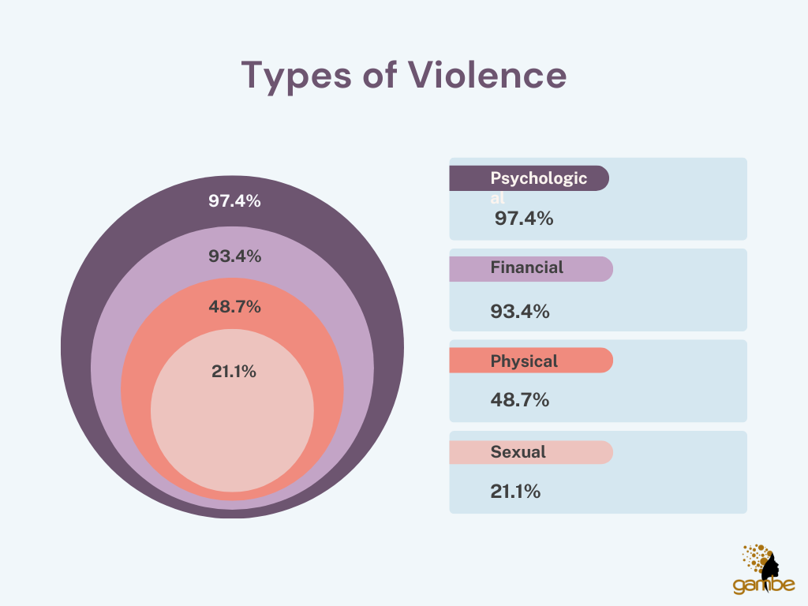

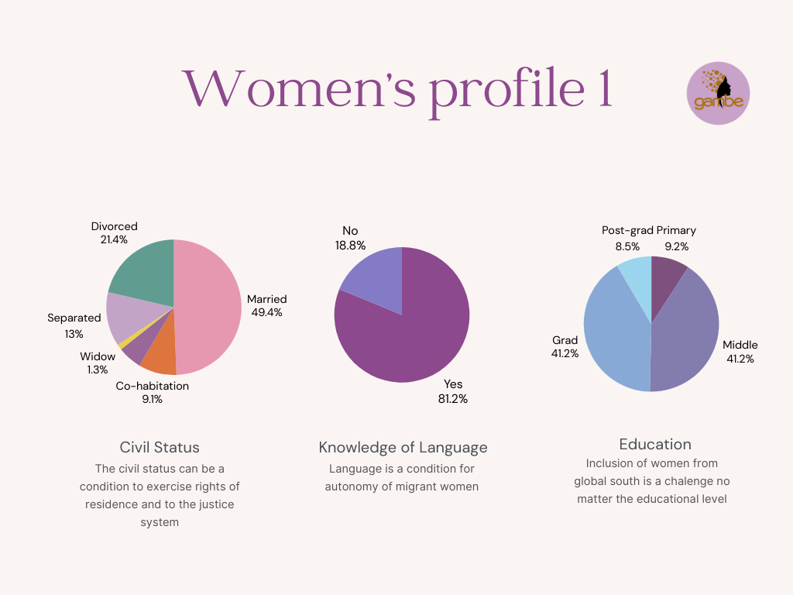

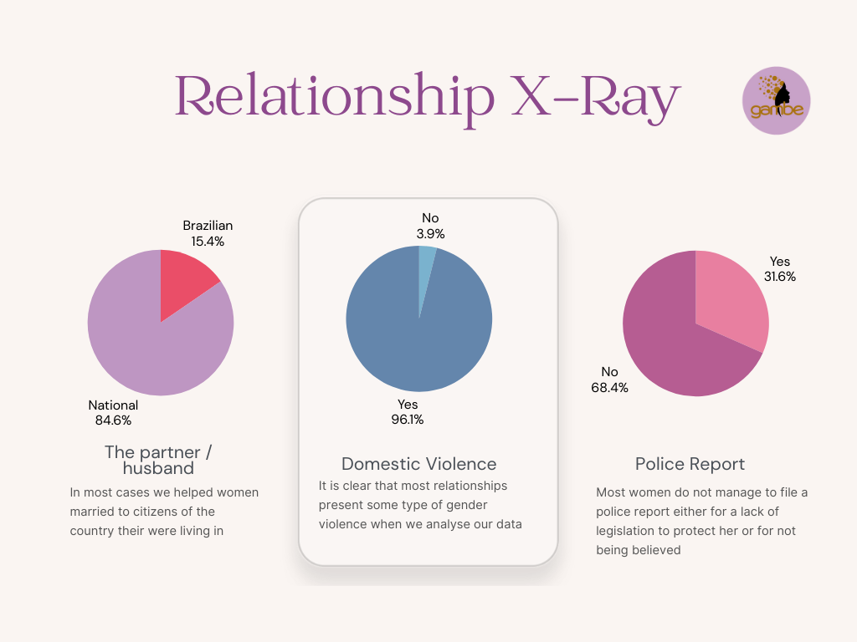
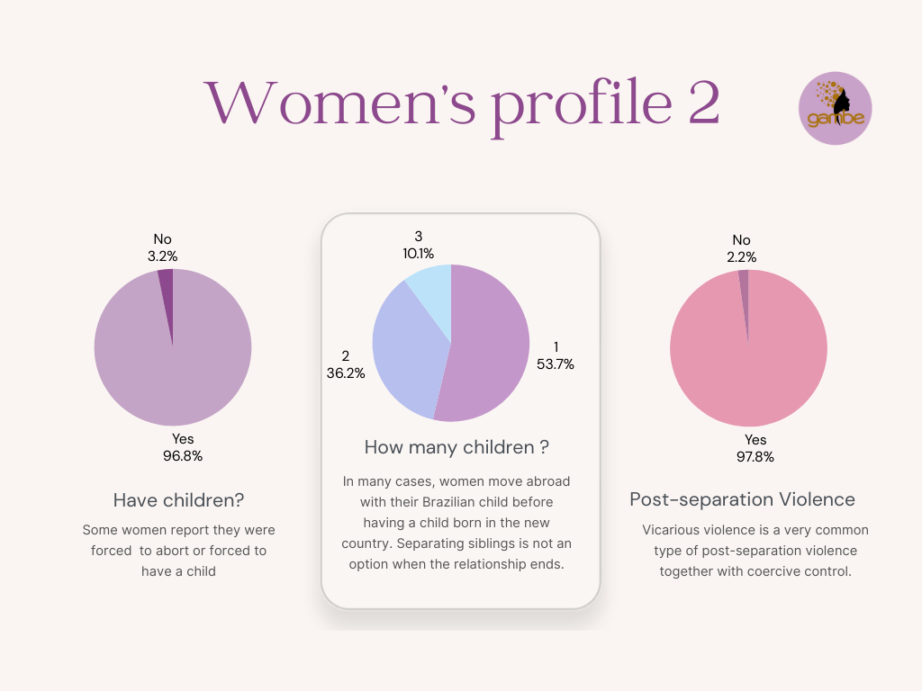

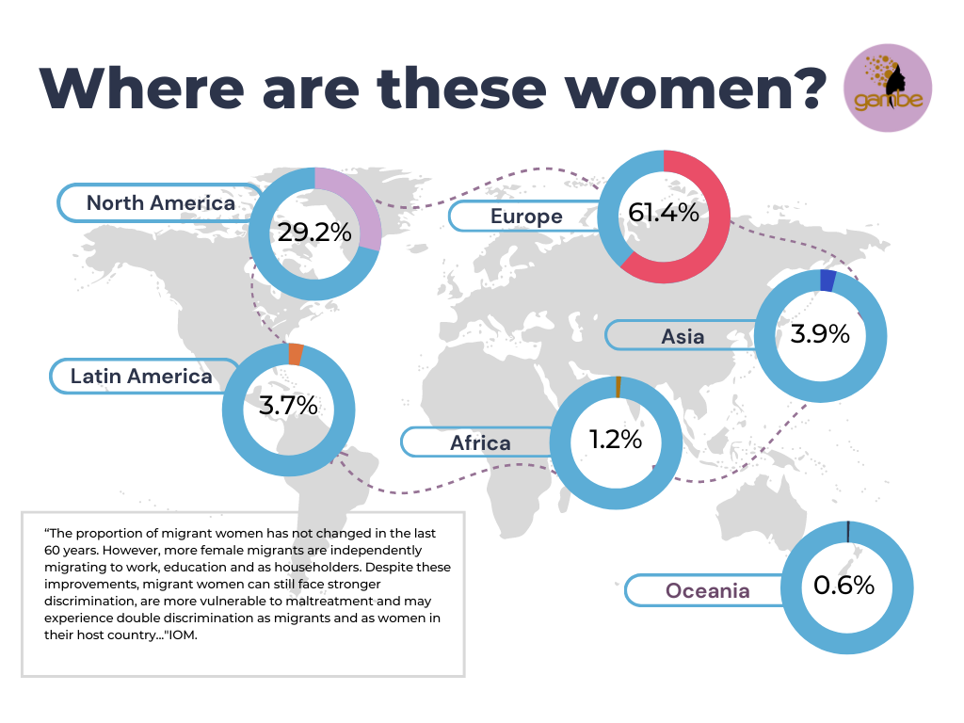

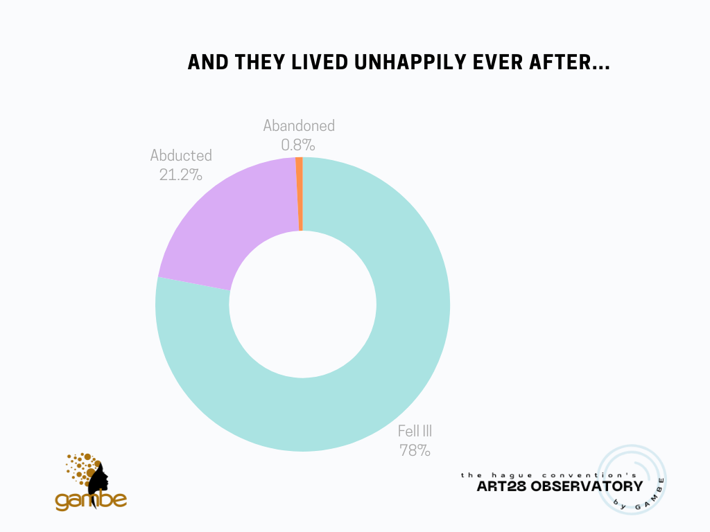

A/HRC/53/36: Custody, violence against women and violence against children - Report of the Special Rapporteur on violence against women and girls, its causes and consequences, Reem Alsalem. Available at: https://www.ohchr.org/en/documents/thematic-reports/ahrc5336-custody-violence-against-women-and-violence-against-children.
Vaccaro, S., & Barea, C. (2009). El pretendido Síndrome de Alienación Parental: un instrumento que perpetúa el maltrato y la violencia. Madrid: Editorial Desclée de Brouwer, SA.
Committee on the Elimination of Discrimination Against Women, General recommendation No. 33 on women’s access to justice, CEDAW/C/GC/33, https://undocs.org/Home/Mobile?FinalSymbol=CEDAW%2FC%2FGC%2F33&Language=E&DeviceType=Desktop&LangRequested=False.
Law No. 12,318, of August 26, 2010. Available at: https://www.planalto.gov.br/ccivil_03/_ato2007-2010/2010/lei/l12318.htm
Combined eighth and ninth periodic reports submitted by Brazil under article 18 of the Convention, due in 2021, CEDAW/C/BRA/8-9 (2022), https://tbinternet.ohchr.org/_layouts/15/treatybodyexternal/Download.aspx?symbolno=CEDAW%2FC%2FBRA%2F8-9&Lang=en
Severi & Villarroel, Análise jurisprudencial dos tribunais da região sudeste sobre a aplicação do instituto: (síndrome da) alienação parental 26(2) (2021).
For more information, see The Seventh Meeting of the Special Commission on the Practical Operation of the 1980 Hague Child Abduction Convention and the 1996 Hague Child Protection Convention – October 2017, International Center for Missing & Exploited Children, https://assets.hcch.net/docs/d0b285f1-5f59-41a6-ad83-8b5cf7a784ce.pdf (2018).
Fernando Horta Tavares et al, Apontamentos para o reconhecimento das uniões homossexuais face ao paradigma do Estado Democrático de Direito (2010) 6:2 Rev Direito GV São Paulo 443–468; Maria Celina Bodin de Moraes, A constitucionalização do direito civil e seus efeitos sobre a responsabilidade civil (2006) 9:29 Rev Direito Estado E Soc 233–258.
Mala Htun, Sex and State: Abortion, Divorce and the Family under Latin American Dictatorships and Democracies (New York: Cambridge University Press, 2003) at 124-125; Eva Alterman Blay, Como as mulheres se construíram como agentes políticas e democráticas: o caso brasileiro, in Eva Alterman Blay & Lúcia Avelar, eds, 50 Anos Fem Argent Bras E Chile (2017) at 88.
Rebecca M. Thomas & James T. Richardson, Parental Alienation Syndrome: 30 Years on and Still Junk Science, 54 Judges J. 22 (2015); Antonio Escudero, Lola Aguilar y Julia de la Cruz, La lógica del Síndrome de Alienación Parental de Gardner, Rev. Asoc. Esp. Neuropsiq. (2008), vol. XXVIII, n.º 102, 283-305, https://scielo.isciii.es/pdf/neuropsiq/v28n2/v28n2a04.pdf. .
See, e.g., Parental Alienation, World Health Organization, https://www.who.int/standards/classifications/frequently-asked-questions/parental-alienation (last visited Apr. 12, 2024).
Joan S. Meier, A Historical Perspective on Parental Alienation Syndrome and Parental Alienation, 6 J. CHILD Custody 232 (2009).
Id.
Id.
Oliveira. A L P de., “SE VOCÊ FICAR COM NOSSOS FILHOS, EU TE MATO!” Violência doméstica e familiar contra a mulher e as disputas de guarda de filhos/as em trâmite nas Varas de Família de Ceilândia/DF, http://www.realp.unb.br/jspui/bitstream/10482/18401/1/2015_AndreLuizPereiradeOliveira.pdf (2015).
CLADEM (Latin American and Caribbean Committee for the Defense of Women’s Rights) https://cladem.org/.
This report was prepared by Anastasia Law, Hyshyama Hamin, Tamara Amoroso Gonsalves and Stella Furquim, with contributions from Myllena Calanzans.
More info at: https://www.planalto.gov.br/ccivil_03/_ato2019-2022/2022/Lei/L14340.htm#:~:text=LEI%20N%C2%BA%2014.340%2C%20DE%2018,a%20suspens%C3%A3o%20do%20poder%20familiar.
Law 13.811/2019, http://www.planalto.gov.br/ccivil_03/_ato2019-2022/2019/lei/L13811.htm.
Proibição de casamento para menor de 16 anos é sancionada pelo governo federal, Senadonoticias, https://www12.senado.leg.br/noticias/materias/2019/03/13/proibicao-de-casamento-para-menor-de-16-anos-e-sancionada-pelo-governo-federal (Mar. 13, 2023).
Brasil Tem Media de 40 Casamentos de Meninas a Cada Dia, Folha De S.Paulo, https://www1.folha.uol.com.br/cotidiano/2024/03/brasil-tem-media-de-40-casamentos-de-meninas-a-cada-dia.shtml#:~:text=IBGE%3A%20Brasil%20tem%20m%C3%A9dia%20de,03%2F2024%20%2D%20Cotidiano%20%2D%20Folha (Mar. 27, 2023),
Id.
Naiana Andrade, Maes sao acusadas de sequestro na fuga de violencia domestica no exterior, Universa Uol, https://www.uol.com.br/universa/noticias/redacao/2023/11/08/maes-sao-acusadas-de-sequestro-na-fuga-de-violencia-domestica-no-exterior.htm (Nov. 08, 2023).
Law No. 13,715, of September 24, 2018, https://legis.senado.leg.br/norma/27481236/publicacao/27481349.
The Global Campaign for Equality in Family Law (GCEFL) is led by a coalition of 8 women’s rights, human rights and faith-based organisations including Equality Now, Act Church of Sweden, CLADEM (Latin American and Caribbean Committee for the Defense of Women’s Rights), Musawah, Muslims for Progressive Values, SOAWR (Solidarity for African Women’s Rights) network represented by FEMNET, Women’s Learning Partnership, and UN Women. GAMBE is a coalition member of the GCEFL. More info: www.equalfamilylaws.org
Economy Data: Brazil, Women, Business and the Law, https://wbl.worldbank.org/en/data/exploreeconomies/brazil/2024 (2024).
A/HRC/53/36: Custody, violence against women and violence against children - Report of the Special Rapporteur on violence against women and girls, its causes and consequences, Reem Alsalem. Available at: https://www.ohchr.org/en/documents/thematic-reports/ahrc5336-custody-violence-against-women-and-violence-against-children.
Input For SR VAWG’s Report On Violence Against Women And Children In Custody Cases In Latin America And The Caribbean December 2022, Equality Now, https://equalitynow.org/resource/un-special-rapporteur-on-violence-against-women-and-girls-its-causes-and-consequences/ (Oct. 12, 2023).
We choose to refer to "false parental alienation syndrome" or "false parental alienation" to indicate the pseudo-scientific nature of the concept, and the fact that it has never been clinically proved or accepted by major medical associations.
Mala Htun, Sex and State: Abortion, Divorce and the Family under Latin American Dictatorships and Democracies 125 (2003); Eva Alterman Blay, Como as mulheres se construíram como agentes políticas e democráticas: o caso brasileiro in Eva Alterman Blay & Lúcia Avelar, eds, 50 Anos Fem Argent Bras E Chile (2017) at 88; Lucas Coelho Brandão, Os movimentos sociais e a Assembléia Nacional Constituinte de 1987-1988: entre a política institucional e a participação popular (Mestrado, 2011) [unpublished] at 95, 125, 138-139 & 164; Vera Fátima Gasparetto, A busca por uma cidadania da imagem: organização, lutas e articulação de políticas públicas no Brasil pela Rede Mulher e Mídia (Mestrado, Universidade Federal de Santa Catarina, 2014) [unpublished] at 45.
SOUSA, Analicia Martins de. Alegações de alienação parental: uma revisão sobre a jurisprudência brasileira. In: Cristiane Souza Borzuk; Rita de Cássia André Martins (Orgs.). Psicologia e processos psicossociais: teoria, pesquisa e extensão. 1ed. Goiânia: Editora Imprensa Universitária, 2019, p. 145-166; SIMIONI, Fabiane. As relações de gênero nas práticas de justiça: igualdade e reconhecimento em processos de guarda de crianças e adolescentes. 2015. Tese (Doutorado em Direito) - Universidade Federal do Rio Grande do Sul, Porto Alegre, 2015; CIARALLO, Cynthia. Atendimento a crianças e adolescentes: práxis, justiça e narrativas na garantia de direitos. In: CONSELHO FEDERAL DE PSICOLOGIA. Debatendo sobre alienação parental: diferentes perspectivas. Brasília: Conselho Federal de Psicologia, 2019, p. 192.
GAMBE, https://www.gambe.org/.
Mala Htun, Sex and State: Abortion, Divorce and the Family under Latin American Dictatorships and Democracies (2003) at 31; See also pages 32-33.

